Q-3-1

1) In June of 2012, New York City Mayor Michael Bloomberg proposed banning the sale of any regular soda or other sugary drinks in containers larger than 16 oz. A fast food chain polled a random sample of 2500 regular customers and found that 63% opposed the ban, 28% supported the ban, and 9% had no opinion.
The value 63 is a ___.
a. population
b. sample
c. parameter
d. statistic

2) In June of 2012, New York City Mayor Michael Bloomberg proposed banning the sale of any regular soda or other sugary drinks in containers larger than 16 oz. A fast food chain polled a random sample of 2500 regular customers and found that 63% opposed the ban, 28% supported the ban, and 9% had no opinion.
What type of plot would be most appropriate to display these data?
a. Histogram
b. Bar graph
c. Dot plot
d. Box plot

3) In June of 2012, New York City Mayor Michael Bloomberg proposed banning the sale of any regular soda or other sugary drinks in containers larger than 16 oz. A fast food chain polled a random sample of 2500 regular customers and found that 63% opposed the ban, 28% supported the ban, and 9% had no opinion.
The 2500 regular fast food chain customers surveyed are the ___.
a. population
b. sample
c. parameter
d. statistic

4) In June of 2012, New York City Mayor Michael Bloomberg proposed banning the sale of any regular soda or other sugary drinks in containers larger than 16 oz. A fast food chain polled a random sample of 2500 regular customers and found that 63% opposed the ban, 28% supported the ban, and 9% had no opinion.
Is this sample representative of the population of ALL New York City residents?
a. Yes, because the sample is a random sample.
b. Yes, because the sample size was large.
c. No, because the entire population was not surveyed.
d. No, because the people in this sample would be more likely to drink regular soda or other sugary drinks in containers larger than 16 oz than the general population.

5) For a survey on affirmative action, researchers selected a random sample of 20 faculty members from a large research university. Faculty in the sample were asked, "Do you favor or oppose using race, religion, sex, color, ethnicity, or national origin as a criterion for college admission?"
Is this sample representative of the entire population of faculty at this large research university?
a. Yes, because the sample is a random sample.
b. No, because the sample size is too small.
c. No, because the sample is a convenience sample.
d. No, because not all faculty were surveyed.

6) Suppose that the proportion of all American adults that fit the medical definition of being obese is 0.23. A large medical clinic would like to determine if the proportion of their patients that are obese is higher than that of all American adults. The clinic takes a simple random sample of 30 of their patients and finds that 9 patients in the sample are obese.
If the clinic had collected a sample of 100 patients instead of 30, would the standard deviation of the simulated null distribution increase, decrease, or remain the same?
a. Increase
b. Decrease
c. Remain the same
d. Cannot be determined

7) Suppose that the proportion of all American adults that fit the medical definition of being obese is 0.23. A large medical clinic would like to determine if the proportion of their patients that are obese is higher than that of all American adults. The clinic takes a simple random sample of 30 of their patients and finds that 9 patients in the sample are obese.
Write the null and alternative hypotheses in proper notation.
a. $H_{0}:̂p$ = 0.30 versus $H_{A}:̂p$ > 0.30
b. $H_{0}:̂p$ = 0.23 versus $H_{A}:̂p$ > 0.23
c. $H_{0}:π$ = 0.30 versus $H_{A}:π$ > 0.30
d. $H_{0}:π$ = 0.23 versus $H_{A}:π$ > 0.23

8) Suppose that the proportion of all American adults that fit the medical definition of being obese is 0.23. A large medical clinic would like to determine if the proportion of their patients that are obese is higher than that of all American adults. The clinic takes a simple random sample of 30 of their patients and finds that 9 patients in the sample are obese.
The researchers created the following simulated null distribution with 1000 trials using theOne Proportionapplet:
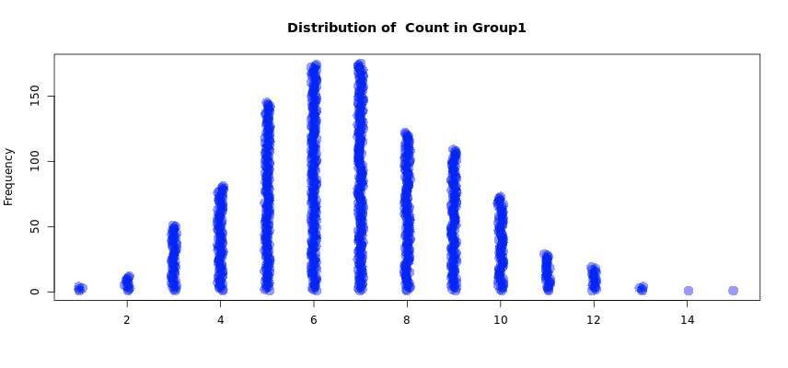

 | 1 | 2 | 3 | 4 | 5 | 6 | 7 | 8 | 9 | 10 | 11 | 12 | 13 | 14 | 15
Counts | 4 | 12 | 51 | 81 | 145 | 174 | 175 | 122 | 109 | 73 | 29 | 19 | 4 | 1 | 1
Where is the distribution centered? Explain why this makes sense.
a. The distribution is centered around 7, since 23% of 30 is around 7.
b. The distribution is centered around 7, since 30% of 30 is around 7.
c. The distribution is centered around 0.23, since the null hypothesis is assumed to be true.
d. The distribution is centered around 0.30, since the null hypothesis is assumed to be true.

9) Suppose that the proportion of all American adults that fit the medical definition of being obese is 0.23. A large medical clinic would like to determine if the proportion of their patients that are obese is higher than that of all American adults. The clinic takes a simple random sample of 30 of their patients and finds that 9 patients in the sample are obese.
The researchers created the following simulated null distribution with 1000 trials using theOne Proportionapplet:
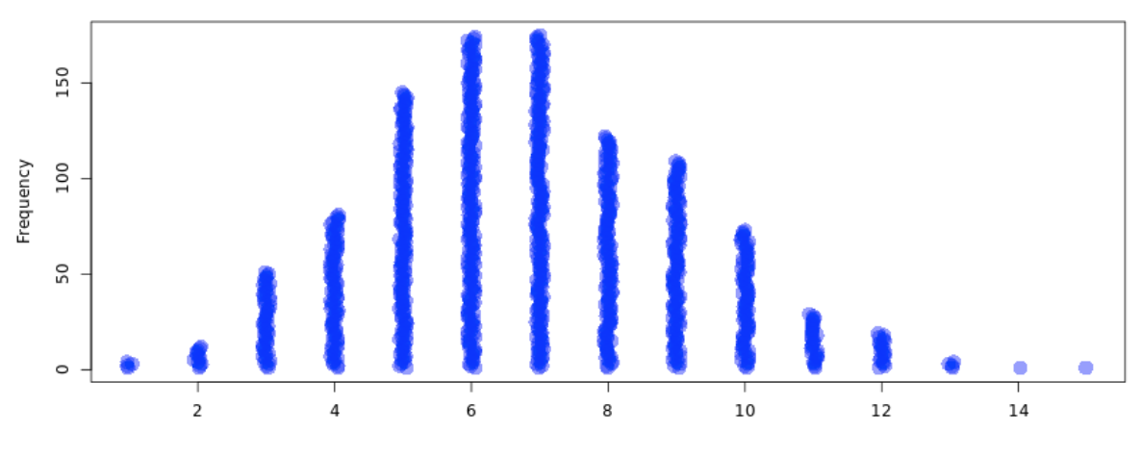

 | 1 | 2 | 3 | 4 | 5 | 6 | 7 | 8 | 9 | 10 | 11 | 12 | 13 | 14 | 15
Counts | 4 | 12 | 51 | 81 | 145 | 174 | 175 | 122 | 109 | 73 | 29 | 19 | 4 | 1 | 1
Looking at the p-value calculated the p-value using the table of counts, what is the conclusion for the hypothesis test in the context of this problem?
a. Little to no evidence exists that more than 23% of all patients at this clinic are obese.
b. Strong evidence exists that 23% of all patients at this clinic are obese.
c. Little to no evidence exists that more than 30% of all patients at this clinic are obese.
d. Strong evidence exists that 30% of all patients at this clinic are obese.

